J. STRAKER, CHADWICK & SONS
ESTABLISHED 1872
Auctioneers, Valuers, Surveyors, Land & Estate Agents

WESTERN VILLA, 2A BRECON ROAD, ABERGAVENNY

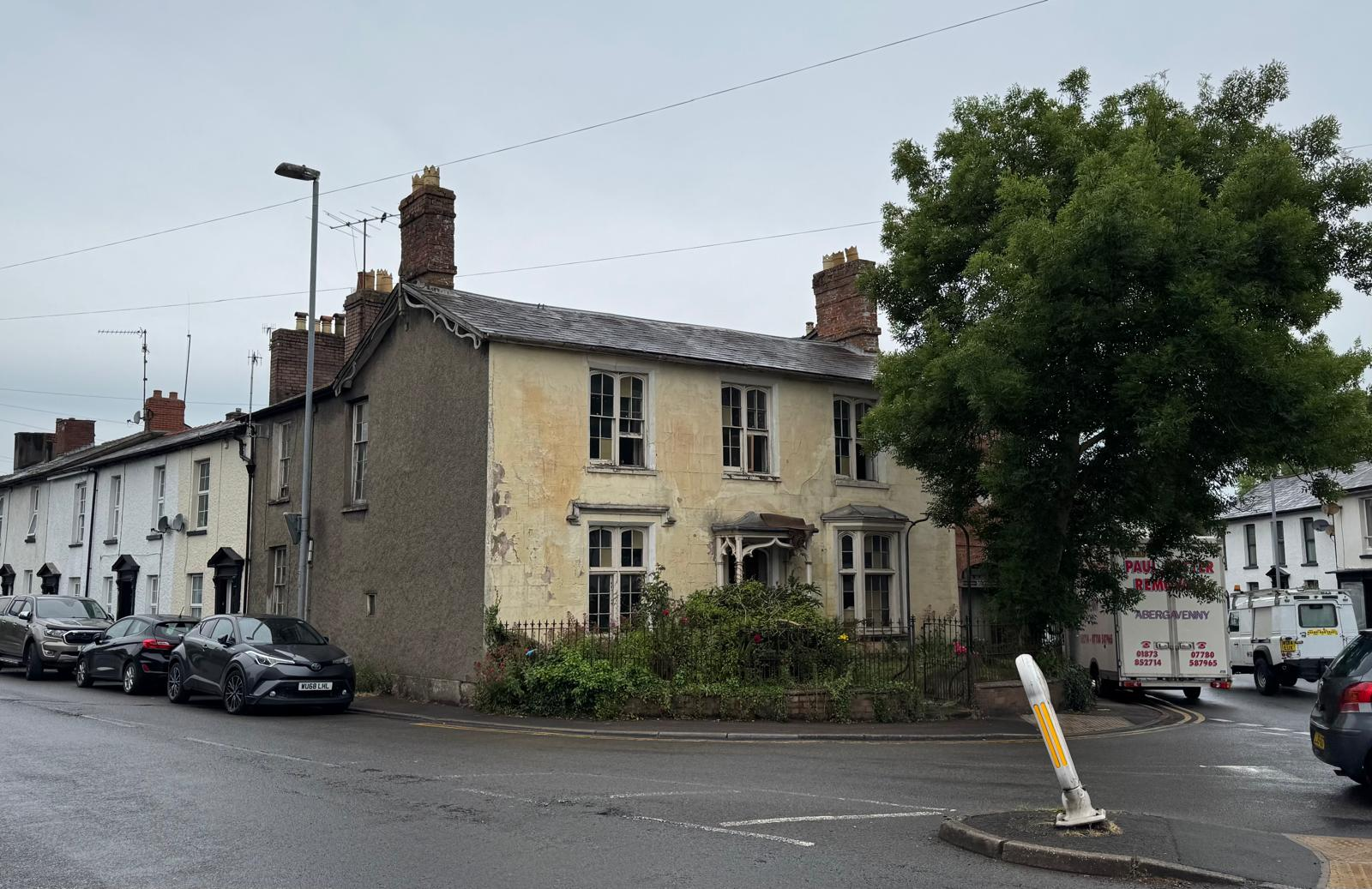

A Grade II listed property believed to date from the 1840’s. In need of complete renovation, the property is full of charming original features and offers enormous potential for sensitive restoration.

FOR SALE BY AUCTION
ON
THURSDAY 30TH OCTOBER 2025 AT 6PM
AT
MONMOUTHSHIRE LIVESTOCK CENTRE, BRYNGWYN, RAGLAN, NP15 2BH
The Auction Rooms, Tiverton Place, Abergavenny, Monmouthshire NP7 5PN
Telephone: 01873 852624
email: lyndon@strakerchadwick.co.uk
SITUATION & DESCRIPTION
Western Villa is set on the junction of Merthyr Road & Brecon Road, Abergavenny, a prominent position on the ‘Western approach/exit’ to/from Abergavenny.

Set back behind a small forecourt with railings and gate to the front.

THE ACCOMMODATION
Entrance with attractive Open Storm Porch, with steps leading to the front door.
Opening to …

ENTRANCE HALL
With moulded ceilings and doors off to …

SITTING ROOM 1
17’8 (5.39) x 13’ (3.96), feature bay window to front with partial shutters and multi pane windows, fireplace, inset alcoves, ceiling moulding, multi pane door.

SITTING ROOM 2
11’10 (3.62) x 13’4 (4.08), aspect to front with attractive multi pane window and partial shutters, fireplace, ceiling moulding, panelled door.

The Entrance Hall continues to the rear Hallway, with stairs off to first floor, doors off to Cellar, and to …

CLOAKROOM
With low level w.c., pedestal wash hand basin, aspect to side.

DINING ROOM
14’11 (4.56) x 11’07 (3.54), built-in cupboards, fireplace, aspect to side with partial shutters, panelled door.

Door off to …

KITCHEN
11’5 (3.50) x 6’5 (1.95), stainless steel sink unit with twin drainers, tiled floor, aspect to side and door to rear Courtyard.

Staircase from Rear Hallway with large multi panelled window to side, built-in cupboard, leading to the …

LANDING
With doors off to …

BEDROOM 1
14’10 (4.53) x 11.9 (3.60), aspect to side (Merthyr Road), fireplace, built-in cupboards and wall safe.

BEDROOM 2
10’11 (3.33) x 11’10 (3.61), aspect to front attractive multi pane sash window, fireplace, cupboard.

BEDROOM 3
8’6 (2.60) x 11’9 (3.58), aspect to front, attractive multi pane sash window.

BEDROOM 4
14’8 (4.48) x 10’9 (3.28), fireplace, aspect to front, attractive multi pane sash window.

Open Arch and steps down from Landing lead to ….

UNFINISHED SPACE/POSSIBLE BATHROOM
18’4 (5.60) x 6’ (1.8). 2 aspects to side, partial plumbing, partially panelled walls.

CELLARS
From the rear Entrance Hall, steps down to Extensive Cellars, with two main rooms. Further steps lead to …

GARAGE
Approx. 19’ x 9’, with inspection pit, aspect and door to rear, folding doors to front.

OUTSIDE
Small enclosed rear Courtyard with former outside w.c., door to Kitchen, and steps to …

1ST FLOOR OPEN TERRACE
Above Garage

SERVICES
Mains electricity, water & drainage.

TENURE
Freehold but we recommend that this aspect be verified with your solicitor.

VIEWING
Please Note: Parts of the Building are in poor repair & extreme caution is advised.

By appointment with the Agents please.
J. Straker Chadwick & Son
The Auction Rooms
Tiverton Place
Abergavenny
Monmouthshire
NP7 5PN
Tel:- 01873 852624
Email: lyndon@strakerchadwick.co.uk

RIGHTS & EASEMENTS
The Property is sold subject to, and with the benefit of all existing rights of way, whether public or private, including rights of way, light, support, drainage, water and electricity supplies and other rights and obligations, easements, quasi easements and restrictive covenants and all existing and proposed wayleaves or masts, pylons, stays, cables, drains and waste, gas or other pipes, whether referred to in the general remarks and stipulations or particulars of sale or not and to
the provisions of any planning scheme of County or Local Authority.

IMPORTANT NOTICE
These particulars are set out as a guideline only. They are intended to give a fair description of the property, but may not be relied upon as a statement or representation of fact. Photographs (and any artists impression) shown only contain parts of the property at the time they were taken. Any areas, measurements or distances are approximate only and should not be relied on as a statement of fact. Any reference to alterations to or use of any part of the property, is not a statement that any necessary planning, building regulations or other consent has been obtained. Descriptions of a property are inevitably subjective and those contained herein are made in good faith as an opinion and not by way of a statement of fact.

METHOD OF SALE
The Property is For Sale by Public Auction

GUIDE PRICE
In the region of £150,000

RESERVE
The property may be subject to a reserve price and the Vendors or their Agents shall be entitled to bid up to the reserve.

CONDITIONS OF SALE
The Conditions of Sale will be deposited at the Office of the Auctioneers and Vendor’s Solicitors, where they are available for inspection in the Saleroom half an hour prior to the Sale. They will not be read at the Sale and any purchaser will be deemed to have knowledge of such Conditions of Sale, whether he inspects them or not, and will bid on this understanding. In the event of any variance between these particulars and the Conditions of Sale, the latter shall apply.

VENDORS SOLICITORS
CAITLIN TEW
GABBS SOLICITORS
32 MONK STREET
ABERGAVENNY
NP7 5NW
TEL: 01873 852432

MONEY LAUNDERING
Prospective Purchasers who attend the auction intending to bid should bring adequate identification with them to prove their identity within the term of the Money Laundering Regulations. Examples of appropriate identification include both passport/driving licence and a recent household utility bill.

